**Leveraging Data to Build Consumer Products**

The combination of more products, more Internet-connected devices, and increased time spent online has caused a spike in the volume of user interaction data. Simultaneously, the virtuous cycle of *more A/B testing and experimentation* → *faster product iteration* → *accelerated development releases* → *compounding product growth (user base, market shares, revenue)*, has fueled internal demand for *unlocking insights from the growing amounts of data generated*.

With the increased focus on driving *data-informed product decisions*, companies generally focus on three outcomes that analytics helps drive:

* *Evaluate the health of the business by building dashboards/reports*
* *Ship the right products and features using A/B testing*
* *Set roadmap and strategy for the product by deep exploratory data analysis*

These outcomes are achieved by defining key north star metrics and goals for products; *creating a scalable data-informed organizational structure*; and *deeply understanding how to drive sustainable growth, retention, stickiness, engagement and monetization for products.*

*Facebook company mission is to give people the power to build community and bring the world closer together.*

*Facebook product vision: People use Facebook to stay connected with friends and family, to discover what's going on in the world, and to share and express what matters to them.*

A set of NorthStar metrics and goals are a must-have. Identifying a top-line metric which best encapsulates *the vision for your product and mission for your company* is critical. This NorthStar metric is one that is a manifestation of usership, is easily measurable, and is associated with the drivers of your business. Closely tied with this metric is the goal of your organization.

eCommerce NorthStar Example: **# of mobile orders delivered**

Facebook NorthStar Example: **# users adding 7 friends in the first 10 days**

B2B NorthStar Example: **# of trial accounts with >3 users active in week 1**

Instacart: **# of weekly users completing their first order**

Goals are important in defining and monitoring success. When a goal is in place, the destination is clear — even though the route may change. Goals help connect your mission to your strategy, roadmaps, initiatives and tactics by tying the single metric you care about most with a target and a time frame during which it can be achieved.

For any company to become truly data-driven, the organizational structure plays an important role in the success. *At Facebook the formula was: # users * TS/users * $$$ /TS = $$$.* Get everyone to join Facebook, keep them deeply engaged with the product and monetize every minute of time that user spend on site.

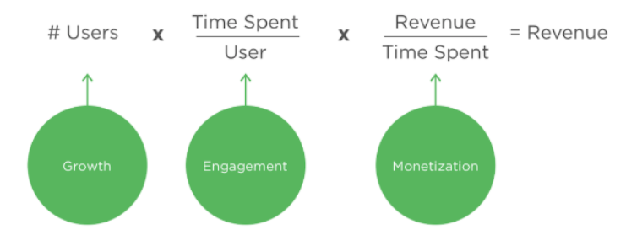

This formula defined the focus for each team, the growth team would focus on the number of users, the engagement team on the time spent per user, and the ads team on dollars per time spent.

With the organizational structure, key goals and metrics established, we explore multiple dimensions of healthy products with a particular focus on how consumer companies should measure aspects such as growth, retention, stickiness and engagement.

Products evolve over time; the characteristics of an early-stage product are quite different from those of a mature one. For strong products, the phases of growth usually resemble an S-curve: in the Early phase, growth is modest and shallow. Then it accelerates as the slope arches upward during the Growth phase. This is followed by a Hyper Growth phase - a period of exponential growth. After maximum growth is reached, growth tapers off and the product begins its Mature phase, during which there is little to no growth. We describe the dynamics of each phase to help you set expectations for your product.

To succeed in the long term, a product must create real value. When it is deeply engaging and has high adoption, users will return to it frequently of their own volition. Most successful, healthy products can grow sustainably for long periods of time because they address fundamental problems. Sustainable growth is growth that can be maintained without exhausting future resources. There is a trade-off between rapid growth today and growth in the future; rapid growth today may exhaust the addressable market and make it impossible to sustain your product over a longer period of time.

Grow sustainably depends on two key factors: **product-market fit** and **positive net growth**.

Retention is the best way to measure product-market fit and by far the best lever for product growth. Without retention, a growing product will eventually be left with no users.

It is essential to monitor metrics to achieve product success. Having established a top-line metric moving that metric in the right direction becomes the top priority. Metric changes are almost always due to one or more of the following factors: product changes, seasonal factors, competition, mix shift, and data quality.

Engagement reflects whether users truly love a product and find value from it, it is the earliest indicator of product-market fit. It is also the most important driver of both retention and sustainable growth. Therefore, a deep understanding of the drivers of engagement is critical to product success. On the most fundamental level, engagement drives both growth and retention. Without an engaged audience a product is rendered useless.